UNIT 6
Lesson 6 – WHAT'S THE WEATHER LIKE?

1 a) There are 4 seasons in a year.
There are 12 months in a year.
Listen to your teacher read the names for months.
Point and say.
Jedna godina ima 4 godišnja doba.
Jedna godina ima 12 mjeseci.
Poslušaj svog učitelja kako čita mjesece u godini.
Pokaži prstom i ponovi.
AUTUMN
jesen
SUMMER
ljeto
SPRING
proljeće
WINTER
zima

12 December  1 January  2 February  3 March | 3 March  4 April  5 May  6 June | 6 June  7 July  8 August  9 September | 9 September  10 October  11 November  12 December

b) Listen to track 6.2.
Write the missing months in the table.
Poslušaj snimku 6.2. Upiši riječi koje nedostaju u prazna polja.

November April January September
(studeni) (travanj) (siječanj) (rujan)

1  January  (siječanj) | 2 February  (veljača) | 3  March  (ožujak) | 4 | 5  May  (svibanj) | 6  June  (lipanj)
7  July  (srpanj) | 8  August  (kolovoz) | 9 | 10 October  (listopad) | 11 | 12  December  (prosinac)

c) Copy the months from 1-12 on the empty lines.
Na prazne crte prepiši mjesece po redu.

1 January
2 __________________
3___________________
4 __________________
5__________________
6 __________________
7__________________
8 _________________
9__________________
10 _________________
11_________________
12 _________________

d) Answer the questions. Odgovori na pitanja.

1 What month were you born?
U kojem si se mjesecu ti rodio?
I was born in ___________________.
Rodio sam se u mjesecu ________________ .

2 What month is now?
Koji je sada mjesec?
It is ___________.
Sada je mjesec _______________ .

3 What is your month of the year?
Koje je tvoj najdraži mjesec u godini?

My favourite month of the year is ________________.
Moj najdraži mjesec u godini je _____________________ .

2 a) There are four seasons of the year.
Listen to your teacher read the words for the seasons.
Point and say.
Jedna godina ima 4 godišnja doba.
Poslušaj svog učitelja kako čita nazive za godišnja doba.
Pokaži prstom i ponovi.

b) Answer the question. Odgovori na pitanja.

1 What season is your birthday?
Koje je godišnje doba kada ti slaviš rođendan?

It is _________________________ .

2 What season is now?
Koje je godišnje doba sada?
It is _________________________ .
3 What is your favourite season?
Koje je tvoje omiljeno godišnje doba?
My favourite season of the year is ___________________ .
.
3 a) What is the weather like? Listen to track 6.3.
Match the pictures to the expressions.
Write the matching picture number on the empty lines.
Kakvo je vrijeme. Poslušaj audio zapis 6.3.
Upari sličicu i izraz koji je opisuje. Napiši točan broj sličice na praznu crtu.
1  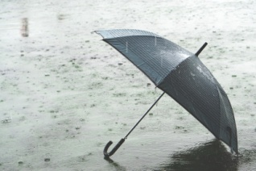 | 2  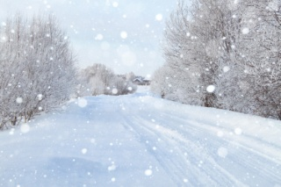 | 3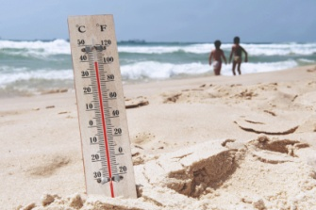 | 4  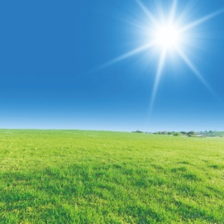
5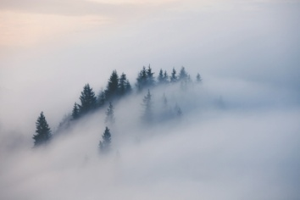 | 6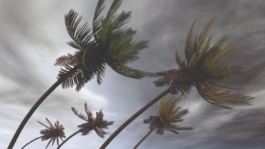 | 7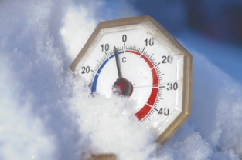 | 8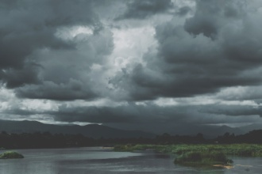

A It's CLOUDY. 8
Oblačno je.

B It's SUNNY. _____
Sunčano je.

C It's SNOWY. _____
Pada snijeg.

D It's HOT. _____
Vruće je

E It's WINDY. _____
Vjetrovito je.

F It' s RAINY. _____
Pada kiša

G It's COLD. _____
Hladno je.

H It's FOGGY. _____
Maglovito je.

c) Answer the questions. Odgovori na pitanja.

1 What is the weather like today?
Kakvo je vrijeme danas?

It is ________________________ today.
Vrijeme danas je _______________ .

2 What was the weather like yesterday?
Kakvo je vrijeme bilo jučer?

The weather yesterday was ___________________ .
Jučer je bilo _________________ .

3 What will the weather be like tomorrow?
Kakvo će vrijeme biti sutra?

It will be _____________________ tomorrow.
Biti će sutra.

d) Finish the sentences. Dovrši rečenice.

I like it when ________________________ .
(Napiši kakvo vrijeme voliš.)

I don’t like it when ___________________ .
(Napiši kakvo vrijeme ne voliš.)

I hate it when _______________________ .
(Napiši kakvo vrijeme ne podnosiš.)
4 c) Play a memory game.
Match the seasons to the pictures.
Cut out the cards.
Odigraj igru memori. Upari slike s nazivima.
Izreži kartice po crtama.

Front side. Prednja strana.

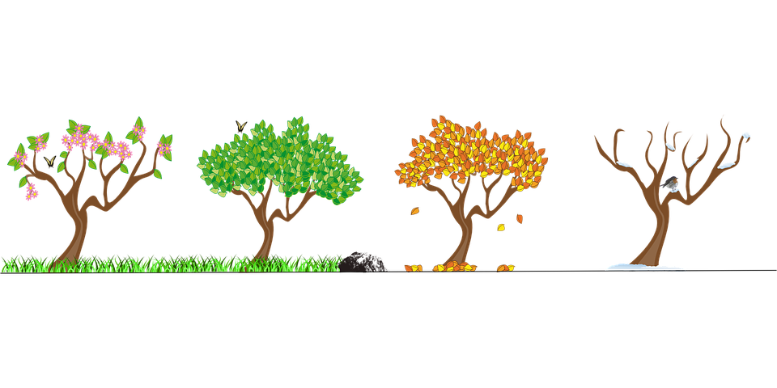
SPRING  PROLJEĆE | SUMMER  LJETO | AUTUMN  JESEN | WINTER  ZIMA
SPRING  PROLJEĆE | SUMMER  LJETO | AUTUMN  JESEN | WINTER  ZIMA

Back side. Poleđina.
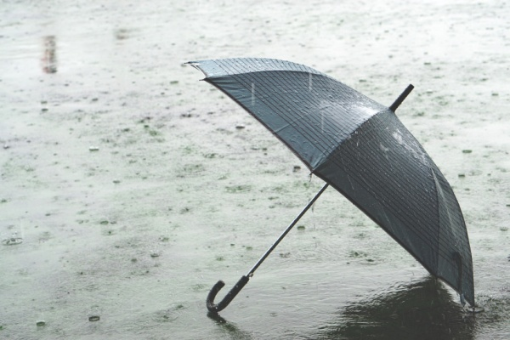 | 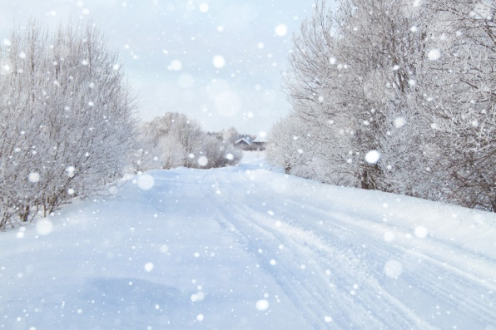 | 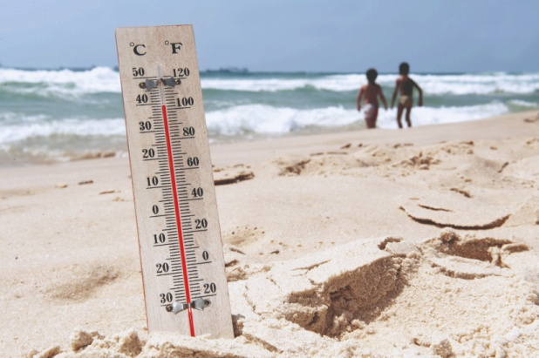 | 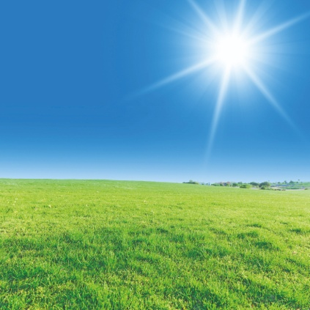
It' s RAINY.  Pada kiša. | It's SNOWY.  Pada snijeg. | It's HOT.  Vruće je. | It's SUNNY.  Sunčano je.
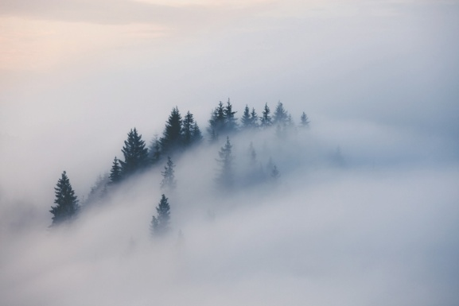 | 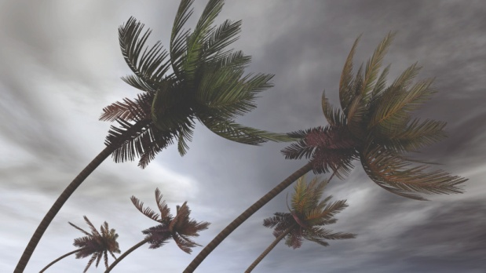 | 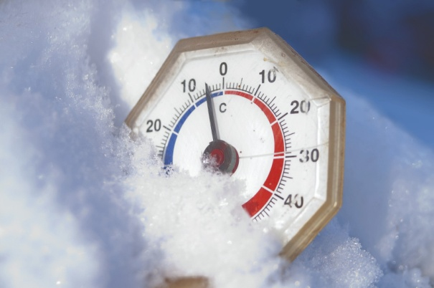 | 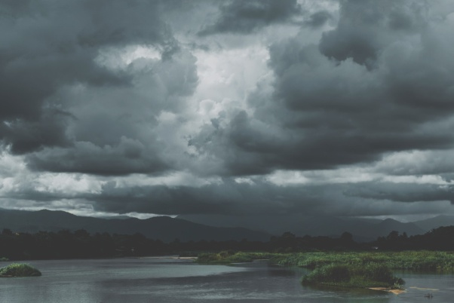
It's FOGGY.  Maglovito je. | It's WINDY.  Vjetrovito je. | It's COLD.  Hladno je.. | It's CLOUDY.  Oblačno je.

